**MODEL PRACTICAL EXAM**

**CS8711 CLOUD COMPUTING LABORATORY**

**NAME: VAISHALI R**

**REG.NO:312217104181**

**20) Install VM (Ubuntu desktop), run a simple java program**

**Output Screenshots:**

1. Create a VM with type as Linux and version as 64 bit using Ubuntu 16.04.07 iso image.

Name of VM: Vaishali-181

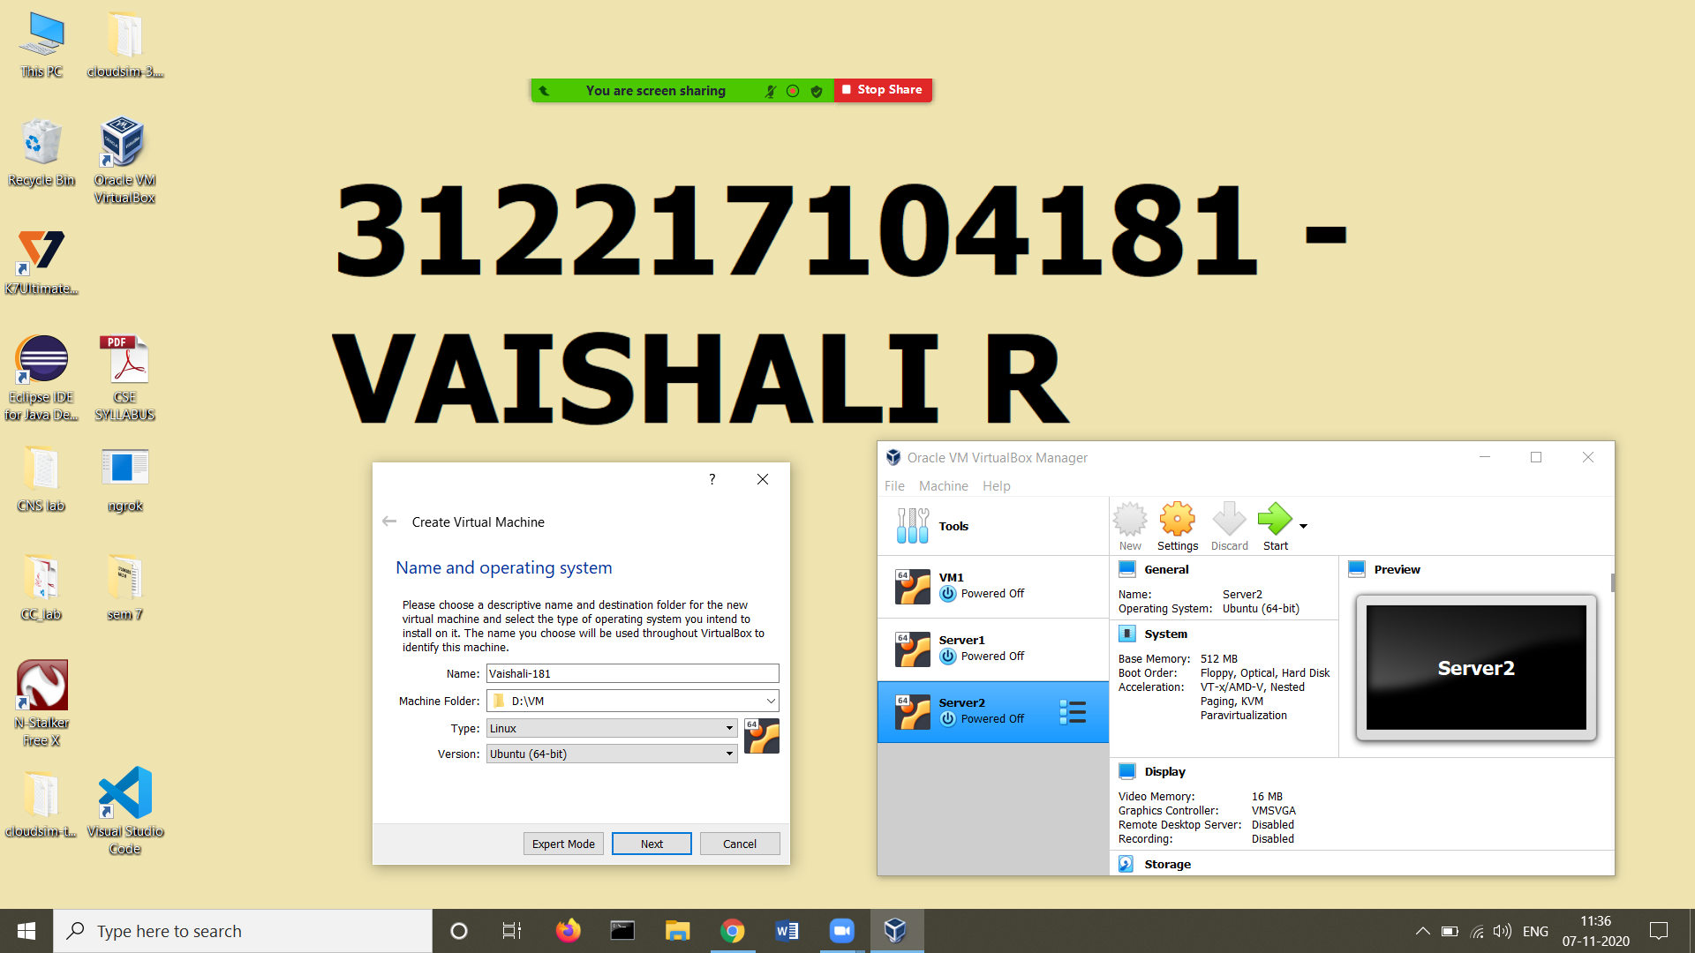

1. Allocate 1024 MB RAM

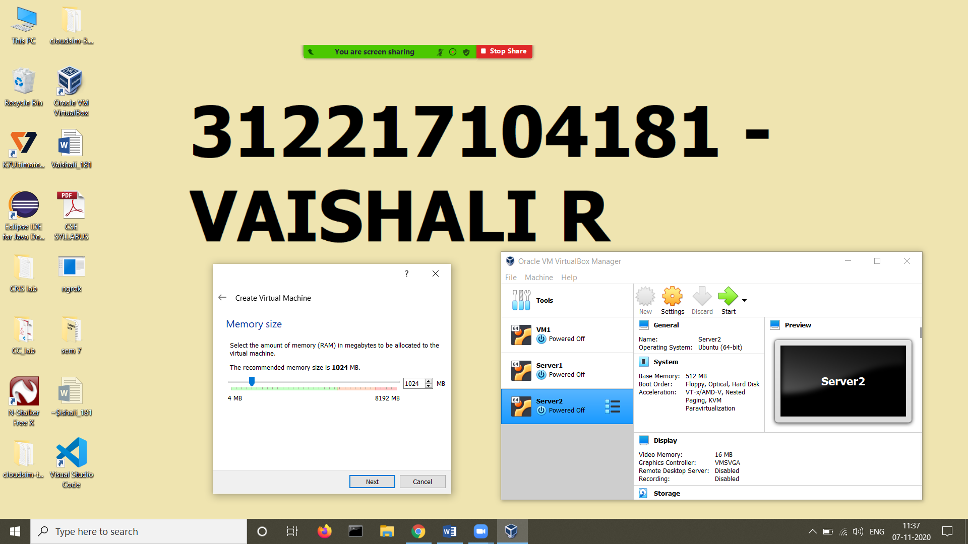

3)Create virtual hard disk of size 10 GB using disk image

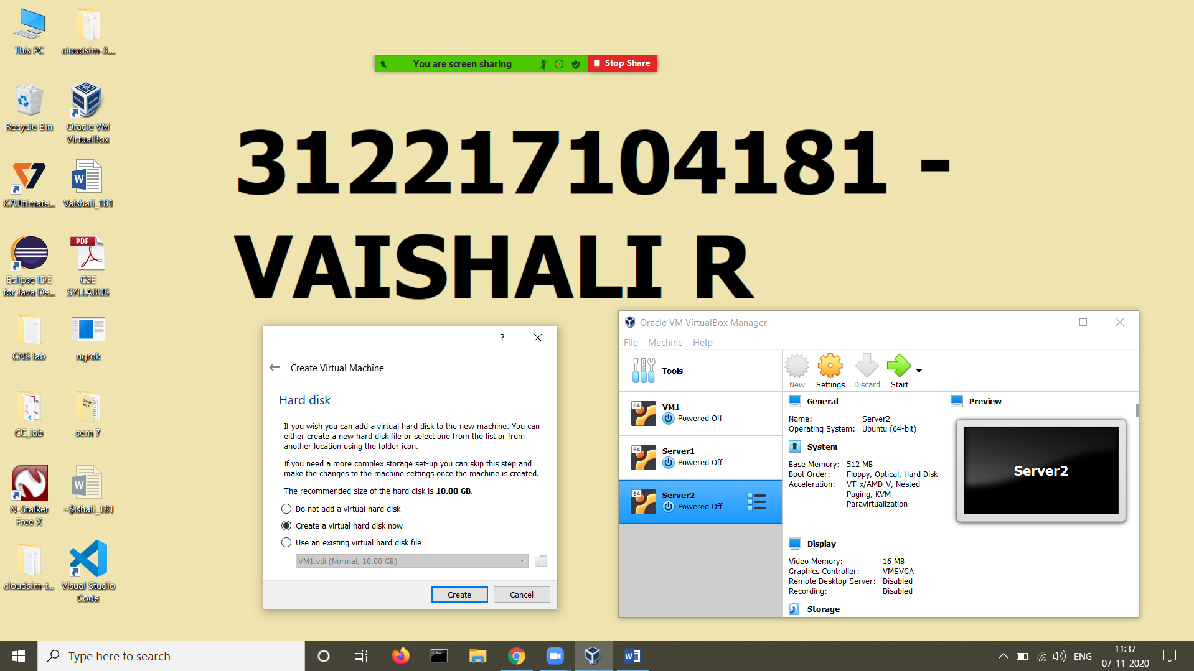

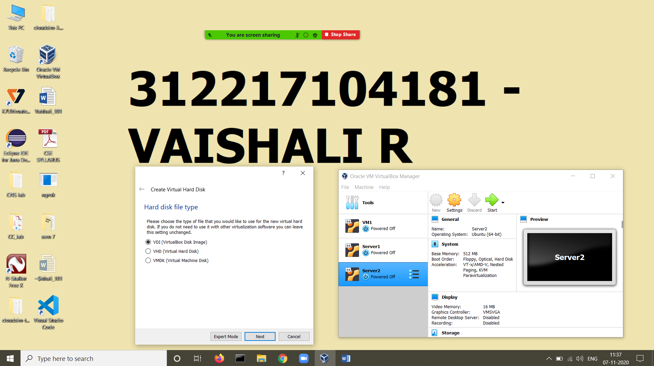

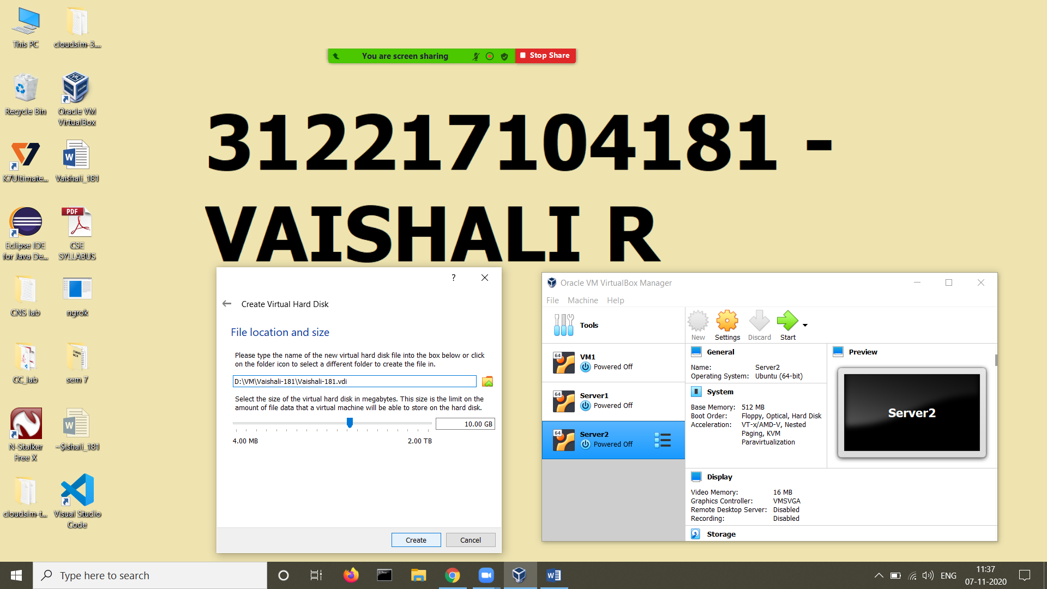

1. Now VM has been created, change the clipboard and drap ‘n drop settings to biredirectional

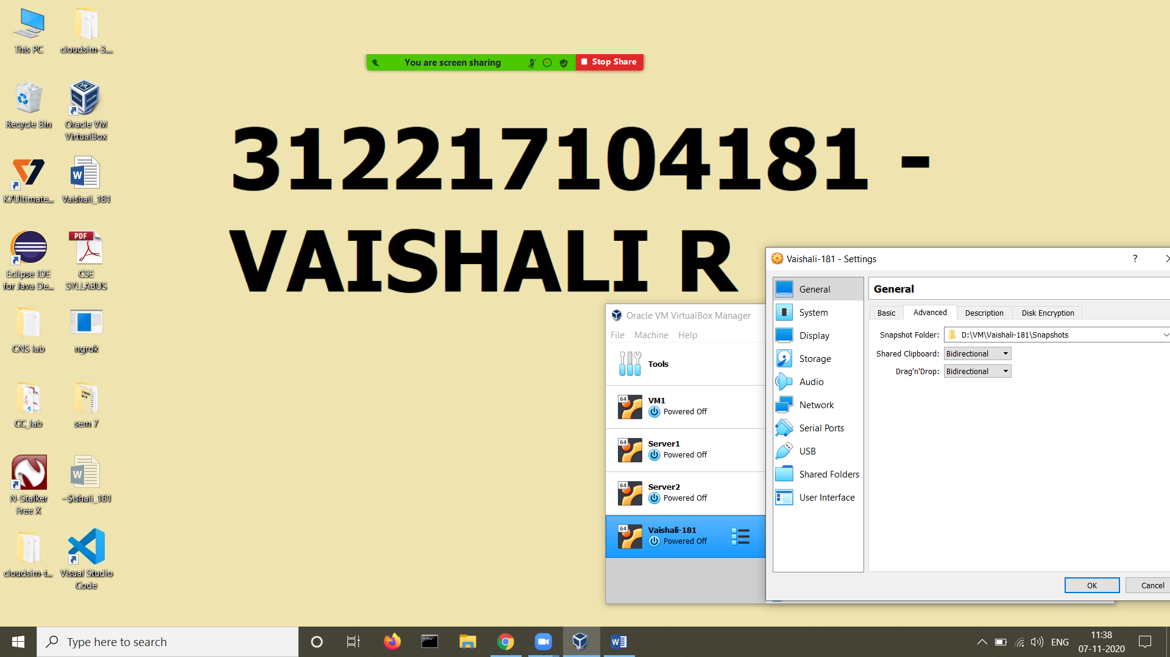

1. Select the corresponding iso image

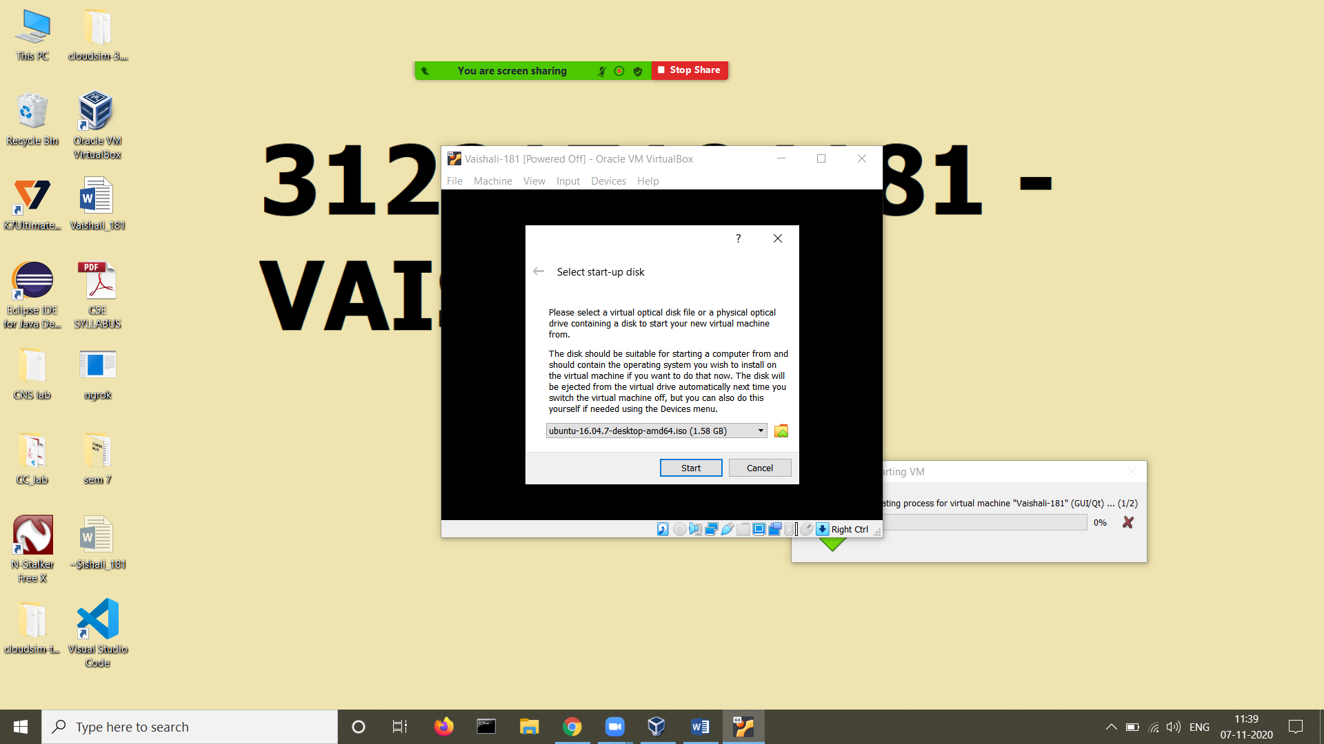

1. Follow the instructions and install ubuntu

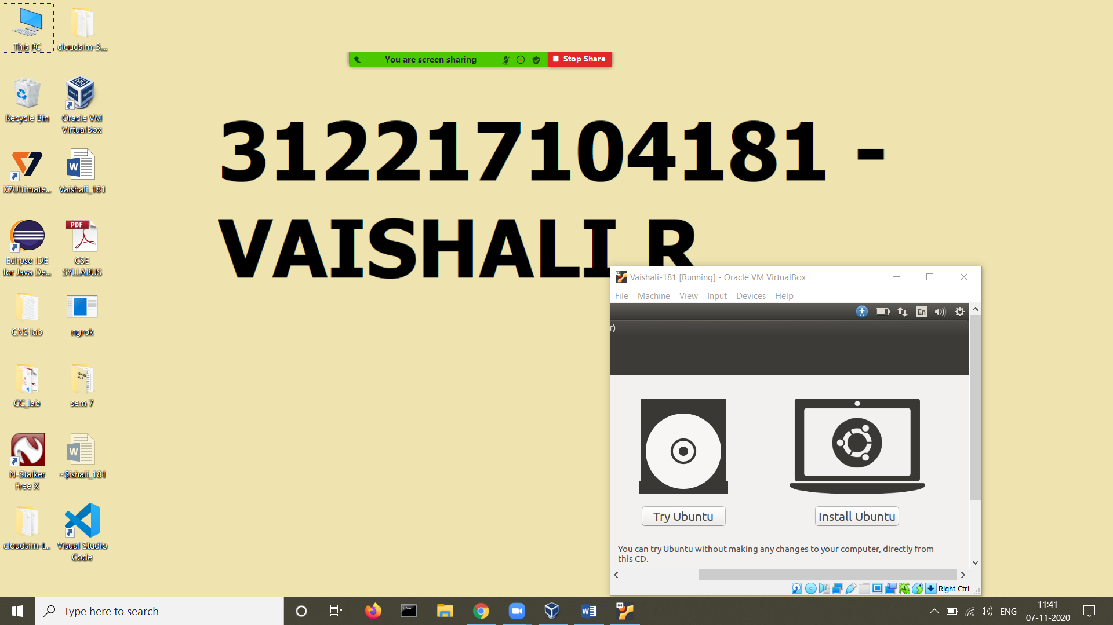

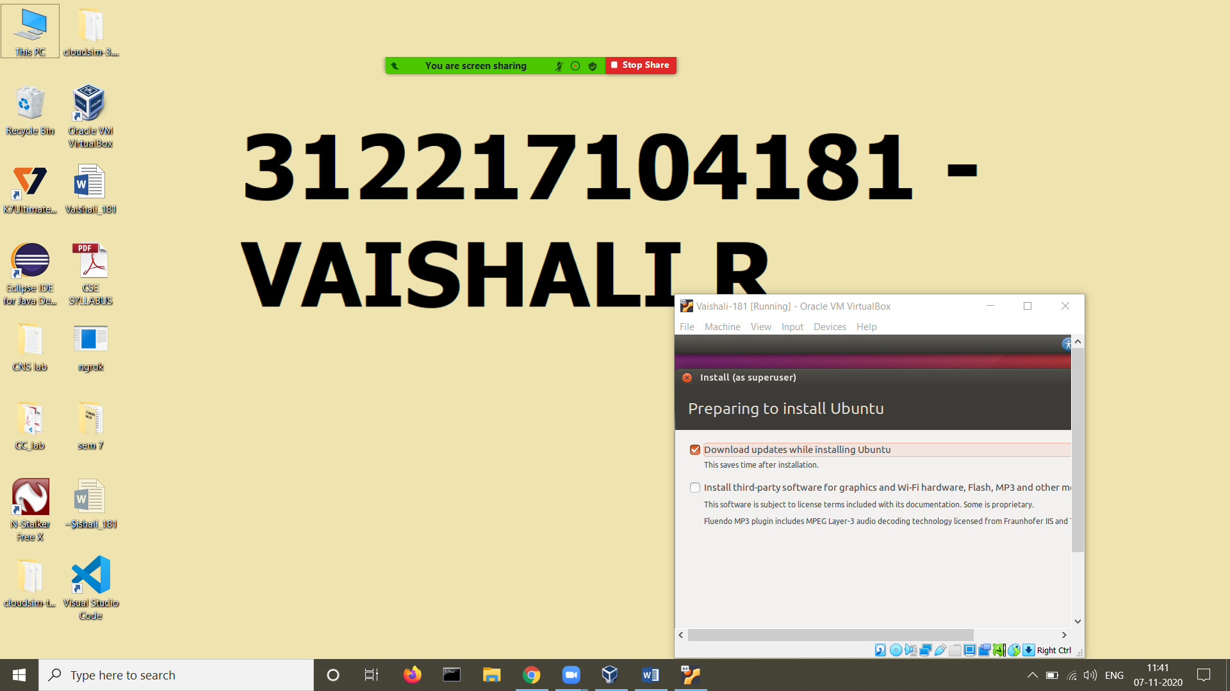

1. Set username (Vaishali-181) and password

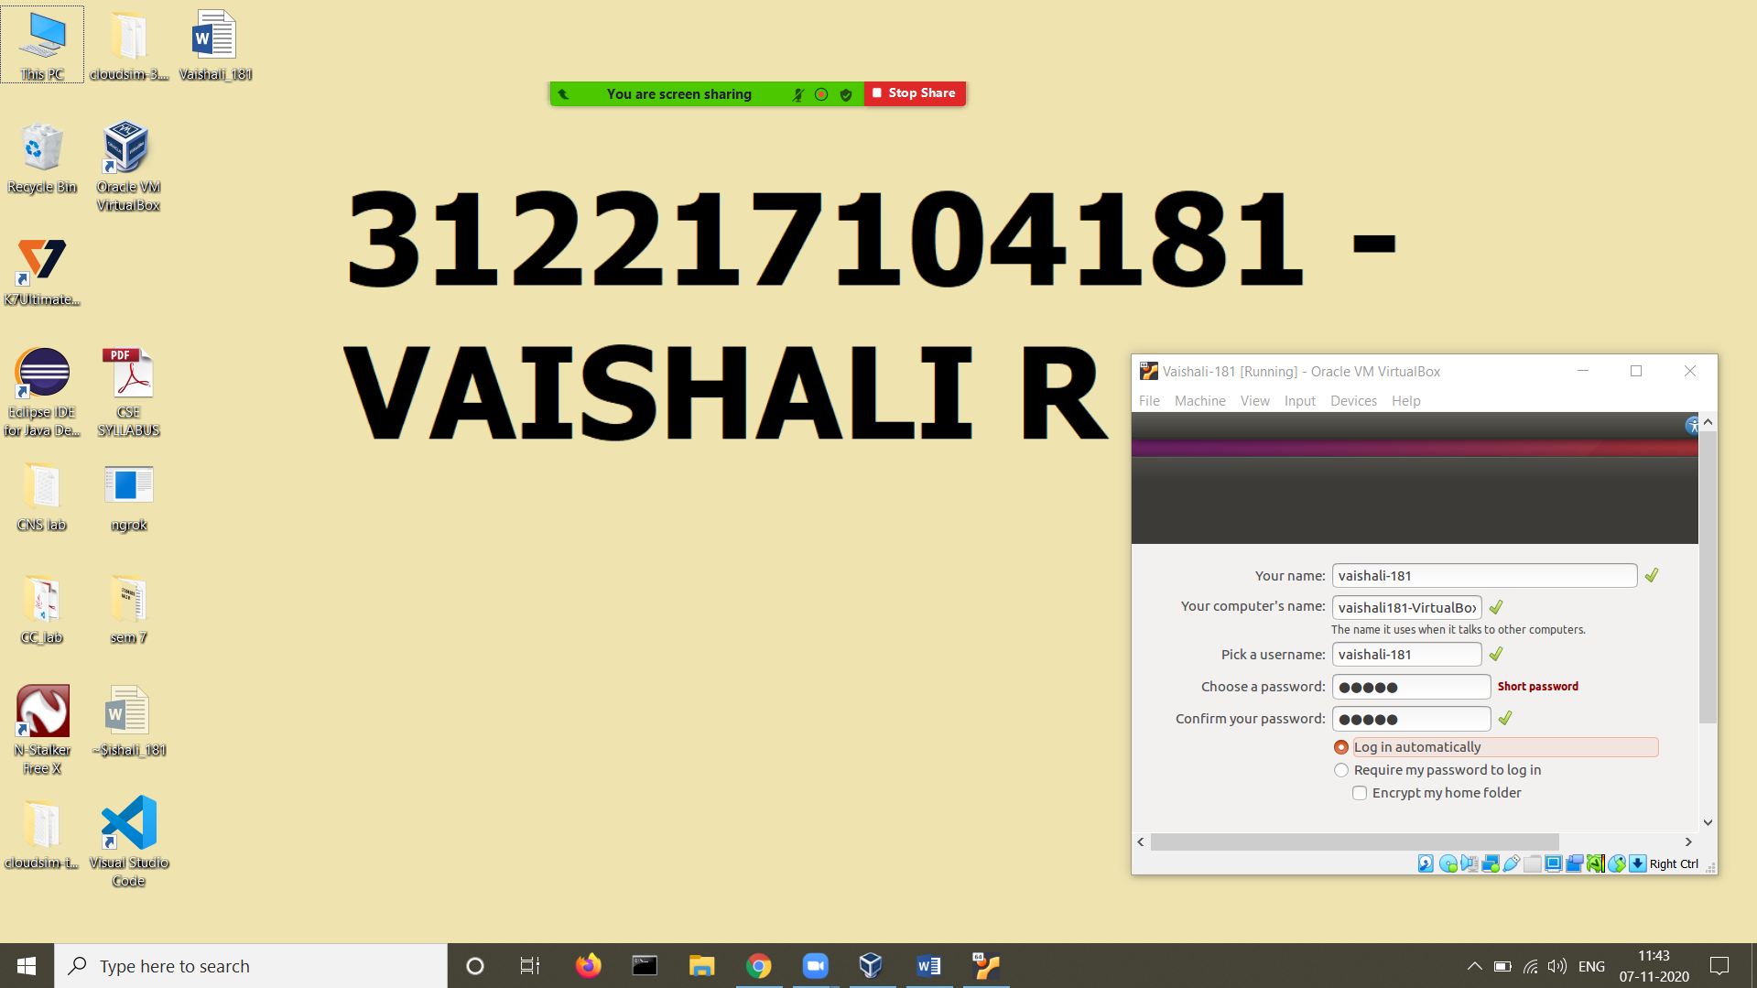

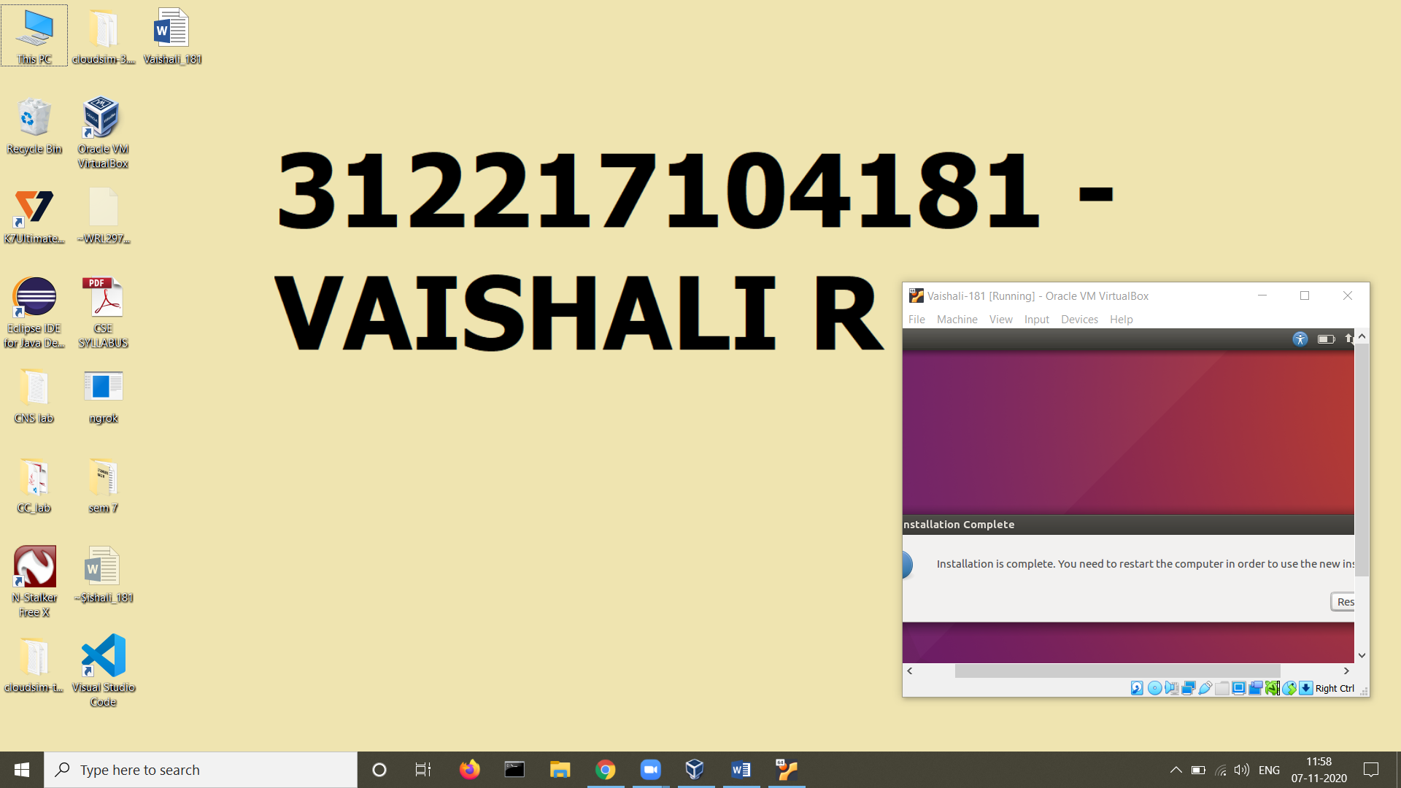

1. Install JRE using “sudo apt install default-jre”

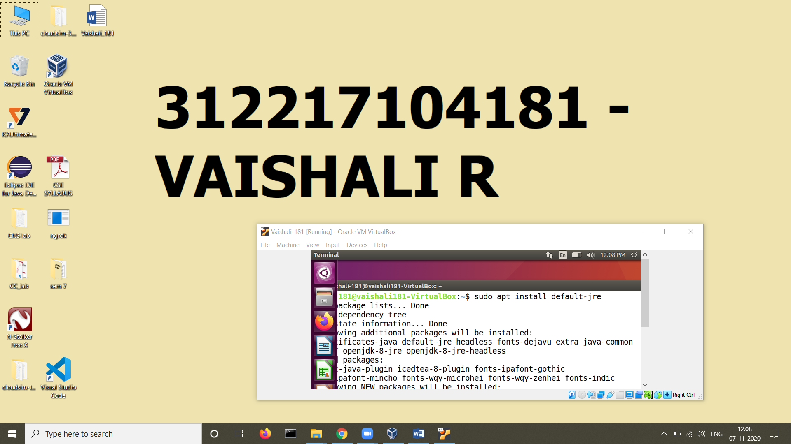

Check version using java -version

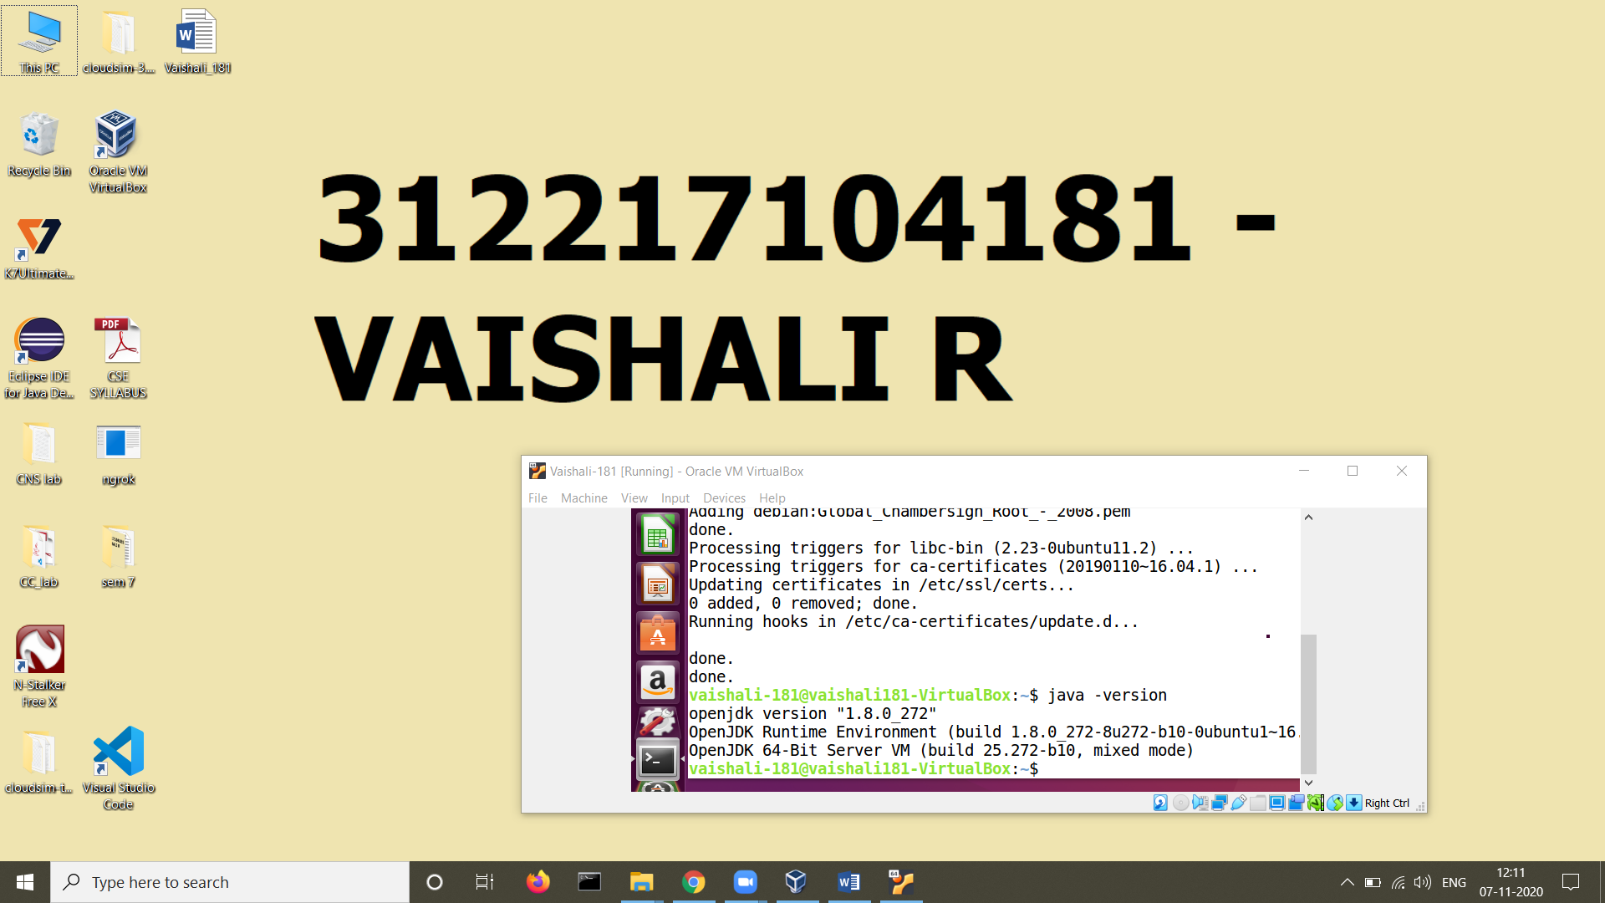

1. Install JDK using “sudo apt install default-jdk”

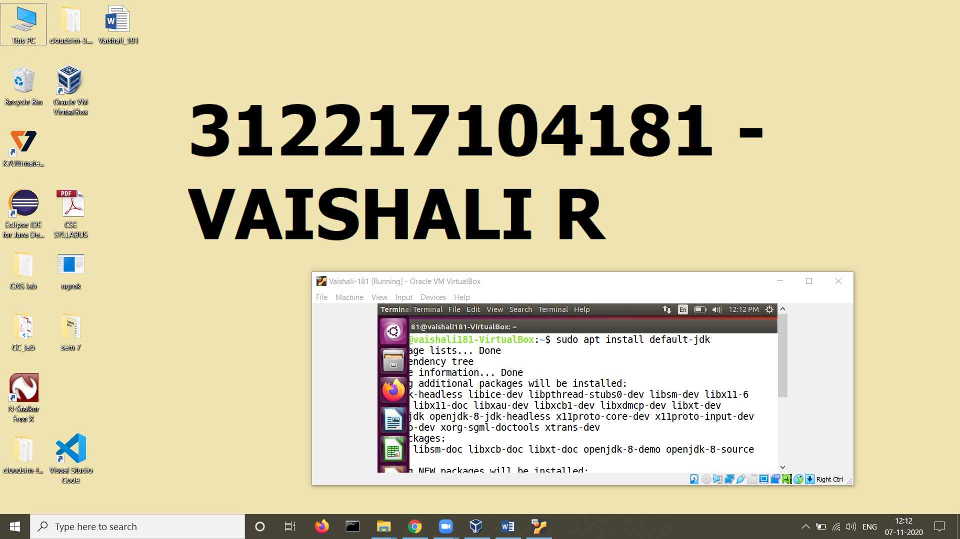

Check version using javac -version

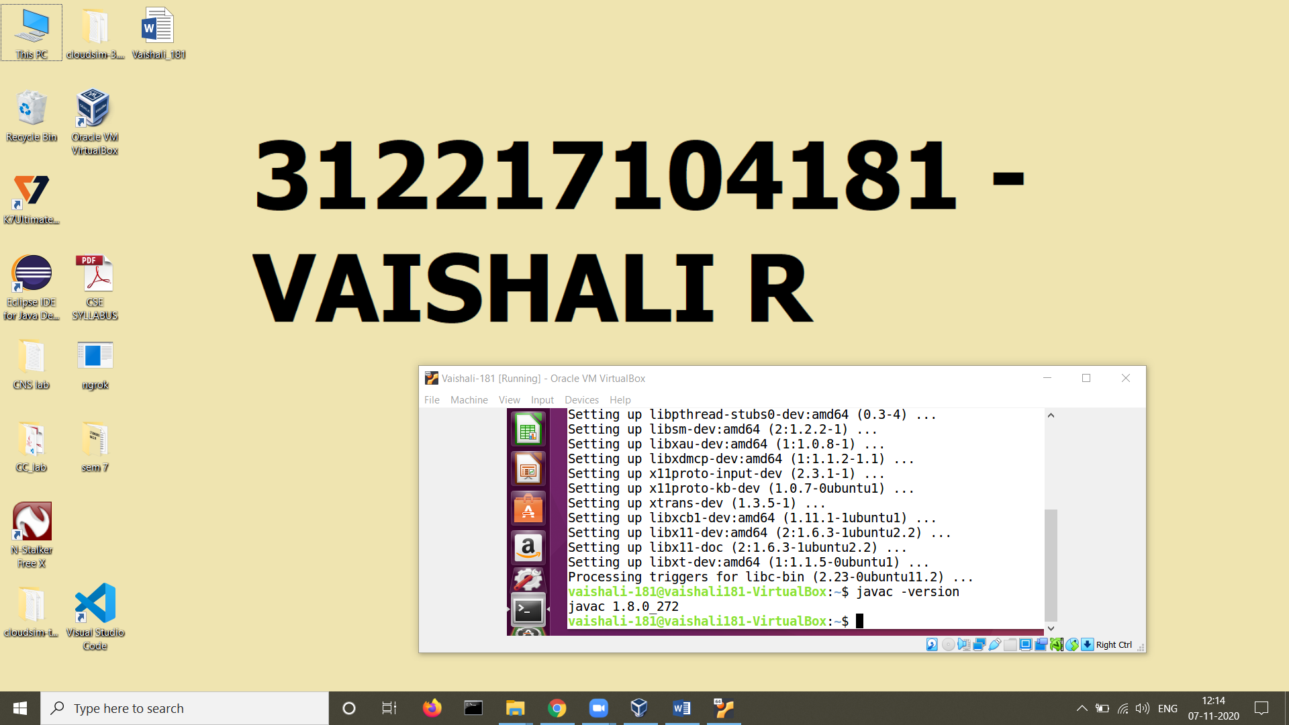

1. Write a simple JAVA program “hello.java”

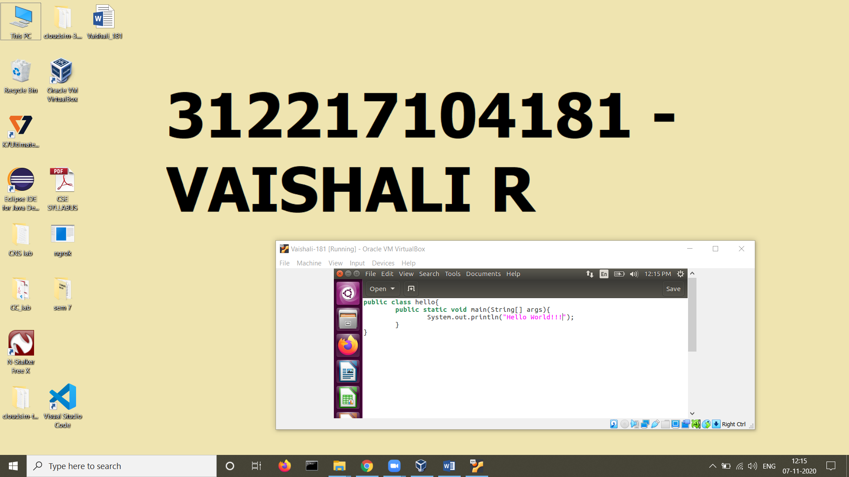

1. Compile and execute hello.java

